RedBud Gypsies Ranch
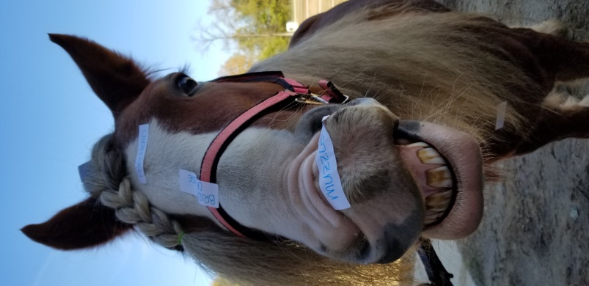
Instructor: Alyssa Carl alyssa@redbudgypsies.com
Location: 1325 Coveney Trail Buchanan, MI 49107
Phone: 574-850-1544
Sign up for the following class and email Alyssa to register for your specific day and time.
The Partnership does not pay for private lessons or horseback riding. If you need more information about what is offered at RedBud Gypsies, call Alyssa.
It is best for students to wear a boot with a slight heel and jeans. Helmets are provided, however if you have an equestrian helmet that is fitted to your son or daughter, they may bring it. Please also have a folder for each student this is brought to every class. There will be handouts provided.
**see note below**
​Classes tentatively begin the week of March 2nd and go through the week of May 6th, with an orientation class the week of January 20th.
Ages: mixed from 5-18
Additional registration at location is required.
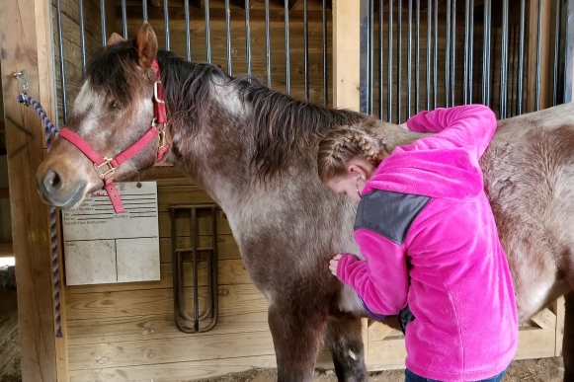
Horse Care
Course Description: Horses need more care than just being ridden. We will be learning what it takes to make a horse’s life the best it can be. The students will keep a journal throughout the semester describing what needs to be looked over and done daily. This class will not only teach horse care, but we will also learn how to identify parts of a horse.
​
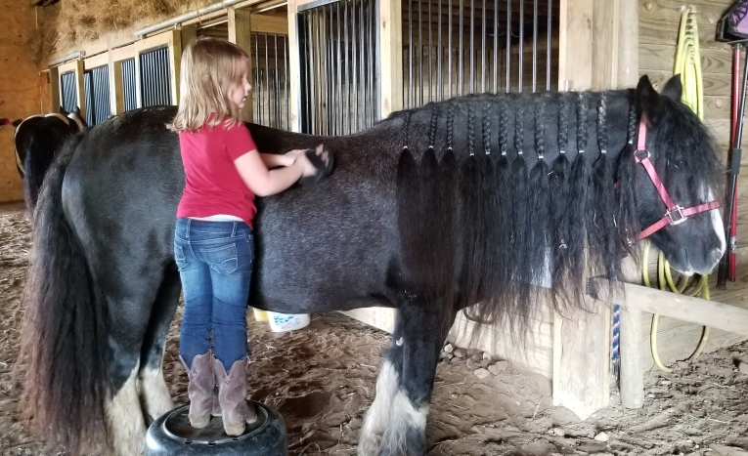
Required Materials
Some kind of boot with a slight heel.
Tennis shoes are NOT allowed.
Jeans
A folder
Optional Materials (provided by student/family)
A helmet for use near horses. Only if it is an approved equestrian helmet. No biking helmets.
Parents are not required to stay for the duration of the class. If you do not stay, please return to pick up your child(ren) at least 5 minutes before the class is set to end.

