Parent Portal Login Instructions:
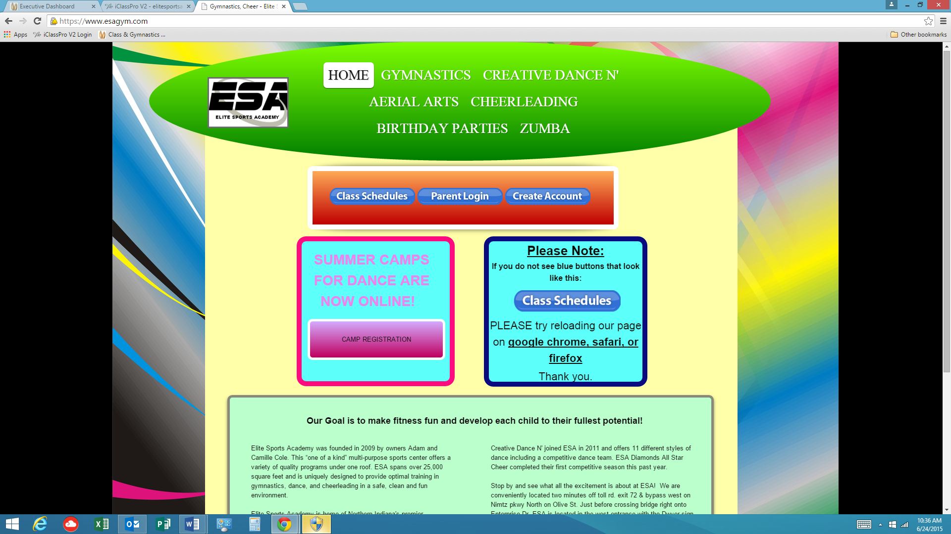
- Go to the home page of our website at www.esagym.com.

- You will see 3 blue oval buttons that look like this:
  - They say: Class Schedules, Parent Login, and Create Account.
  - You may click on any of them.
- You will now be at the parent portal login screen. It looks like this: 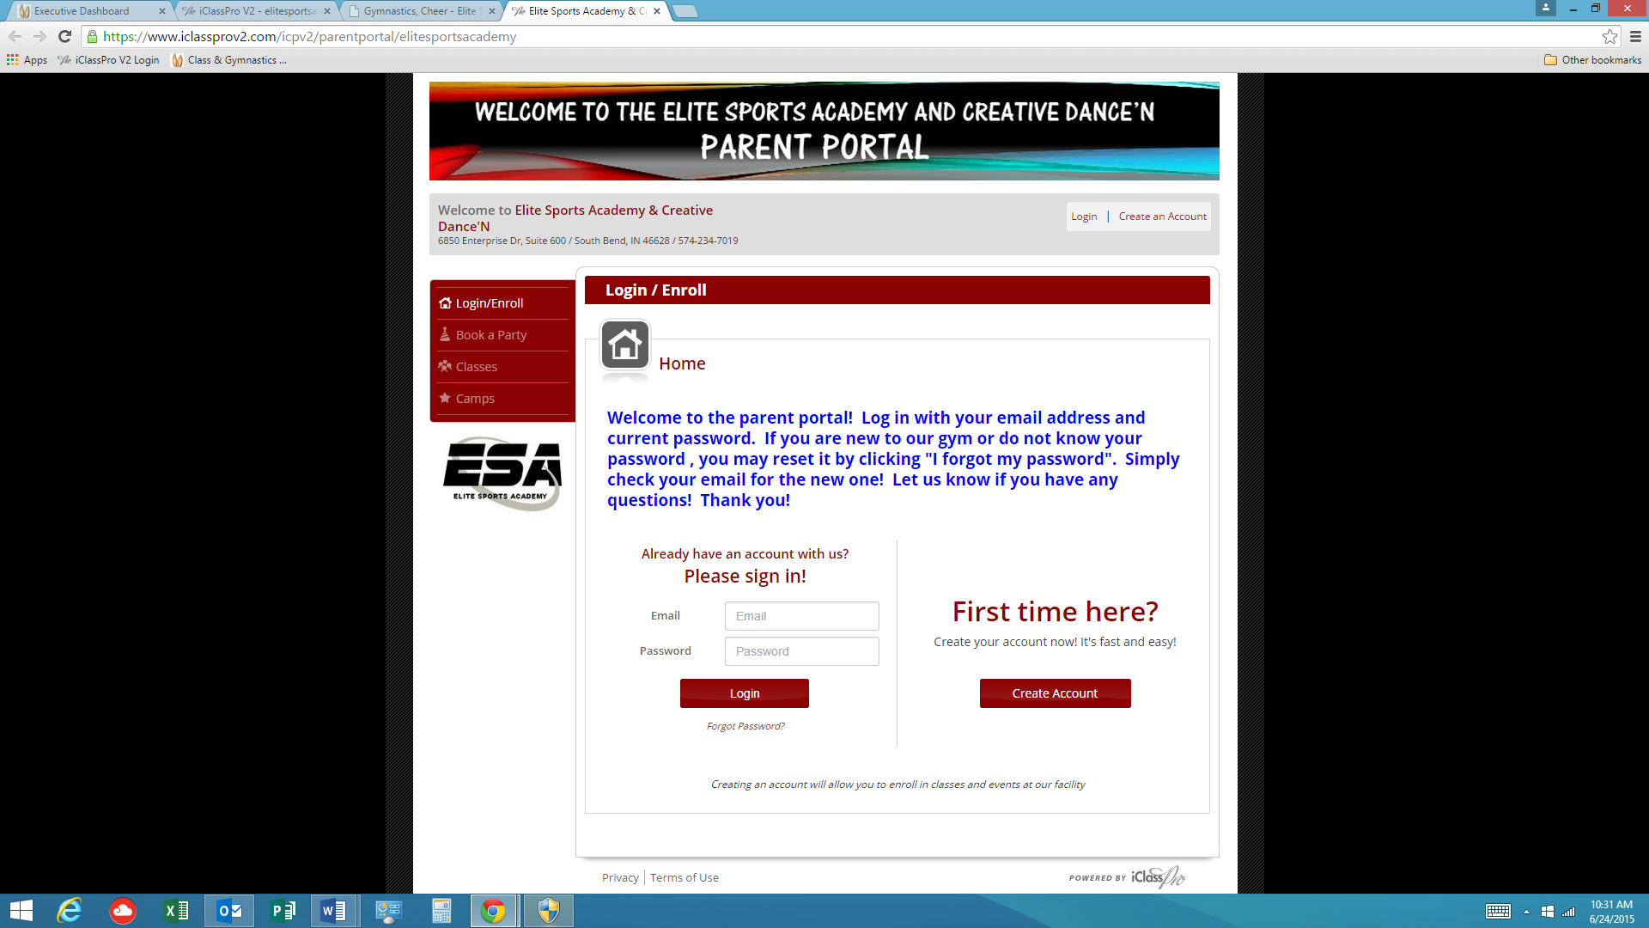

- Click on CREATE ACCOUNT.

- Fill in all of the appropriate questions (guardian, address, phone numbers, etc.) and then click on create account at the bottom of the screen.
- You will now be prompted to sign the electronic waivers.
- Add your child’s information and choose save student.
- To add credit/debit card information, please click “payment” from the menu on the left.
- You may add classes, request to drop classes, book a party and sign up for summer camps.
- If your child will be participating on one of our competitive teams (cheer, gymnastics, or dance), we will need to enroll your student onto the team here at the gym.
- If you have any questions, please ask! Thank you!

