Old English and American Country Dancing Syllabus
Fall 2017
Instructor Information
Instructor Phone Email Class Location & Hours
Rebecca Dubs (269) 340-2845 dubsr01@gmail.com Five Pines Ministries
6597 Smith Rd, Berrien Center, MI, 49102
Wednesdays: 5:30 pm – 6:45 pm
General Information
Course Description
This class is an appreciation of social dancing as it relates to history. Throughout the course, students will get to experience various forms of social line dancing as early as 1650s up to the 21st century and their history, from the court dances of the renaissance era such as Gathering Peascods or Mr. Beveridge’s Maggot (seen in Pride and Prejudice BBC 1994), to the dances of the Revolutionary War like The Shrewsbury Lasses, through the Civil War Era with Soldier’s Joy, ending with the line dances of today such as Michael Jackson’s Thriller. (Videos for reference can be found at the end of the syllabus.)
Class Size
The class has a 15-students minimum requirement.
**Please Note: The partnership cannot pay for classes that students do not complete, so choose wisely; if you do not take the class off of your student's schedule by the deadline, you may be asked to pay for the class time and materials incurred prior to dropping the class.**
Course Materials
- Tennis Shoes
- Students may need to purchase or provide their own costume pieces, depending on supplies. (Costumes for reference can be found at the end of the syllabus.)
- Water bottles
Class Run Time
The course is 16 weeks long from September 6, 2017 – December 22, 2017** with 15 classes. The final class will be a performance and participation ball for the students’ friends and family on December 22, 2017 at 7 pm. The students will be expected to arrive at 5:30 pm to review the dances before their performance at 7 pm. **NOTE** DUE TO THANKSGIVING AND THE FINAL PERFORMANCE, NO CLASS WILL BE HELD ON NOVEMBER 22, 2017 OR DECEMBER 20, 2017. Course schedule can be found at the end of the syllabus.
Field Trip Information
The class includes two field trips. The first field trip is to Dollinger’s Farm Reenactment on October 7, 2017 at 7420 E Hansel Rd, Channahon, IL, 60410. The second field trip is to the Joyeux Noel Reenactment - A French Christmas in the Old Historic Fort Wayne on November 25, 2017 at 1201 Spy Run Ave, Fort Wayne, IN 46805. The students will be required to attend ONE of these two reenactments, and will need to let the instructor know by the 2nd week of class which one they are attending, as the field trips are 25% of their grade. If there are extenuating circumstances, the teacher must be notified ASAP so arrangements can be made. If they go to both reenactments, they will receive one attendance grade credit if the need arises.
Important dates are as follows:
- October 7, 2017 – Dollinger’s Farm Reenactment
- November 22, 2017 – NO CLASS
- November 25, 2017 – Joyeux Noel Ft Wayne Reenactment
- December 20, 2017 – NO CLASS
- December 22, 2017 – Final Performance Ball (students are expected to arrive at 5:30 pm)
Grading Scale
A | 93.0% and up
A- | 90.0-92.99%
B+ | 87.0-89.99%
B | 83.0-86.99%
B- | 80.0-82.99%
C+ | 77.0-79.99%
C | 73.0-76.99%
C- | 70.0-72.99%
D | Fail

Expectations
Attendance:
- By state requirements, three missed classes result in automatic failure barring extenuating circumstances.
- Up to two missed classes may be redeemed by finishing the required homework before the following class. (Homework will be emailed to the students’ parents by the end of the following day of the missed class). Failure to turn in homework will result in the dropping of a letter grade barring extenuating circumstances. (A down to B, B down to C, C down to failing grade.)
- If a student misses a class, they are expected to notify the instructor ASAP.
- Unless arrangements have been made with the instructor prior to the start of class, 10 minutes late results in 1 tardy. 2 tardies results in 1 absence grade, to be made up by homework at the teacher’s discretion. (NOTE: It is in the student’s best interest to notify the instructor as soon as they know they will be late or absent.)
Assessment
- Final Performance:
  - Performance and Participation Ball 50%
- Reenactments:
  - Dollinger’s Farm OR
  - Joyeux Noel Reenactments 25%
- Participation:
  - Attitude of Learning 15%
- Homework:
  - John Playford Paper (1 page for 5th-7th, 2 pages for 8th-12th: Student’s Name, Instructor’s Name – Class Title, Due Date, Double Space, Font 12 – *Due Sep 27*)
5%
  - Cecil Sharp Paper (1 page for 5th-7th, 2 pages for 8th-12th: Name’s Name, Instructor’s Name – Class Title, Due Date, Double Space, Font 12 – *Due Oct 25*)
5%
  - Final Course Evaluation (Due Dec 22)
- Extra Credit Opportunities:
  - Students interested in learning to dance call will be given an opportunity to sign up for a Student Teaching Dance Slot starting at week 6 for extra credit.
End of Semester: Finished Work
- Evidence of Learning: post-test score improvements and class/parent/public performance.

***The instructor reserves the right to assign homework and make syllabus revisions as the need arises. ***

By signing this, I agree that I have read, understand, and agree with the terms laid forth by this syllabus.
Parent’s/Guardian’s Signature:
(Print)_______________________________________________________________________________________

(Sign)________________________________________________________________________________________
Student’s Signature(s):
- ______________________________________________________________________________________

- ______________________________________________________________________________________

- ______________________________________________________________________________________

- ______________________________________________________________________________________

- ______________________________________________________________________________________

Course Schedule
Week | Agenda
Week 1 | Renaissance
September 6, 2017 | - Thriller – Part 1  - Renaissance Dances  - Pretest  *DUE: Class Emergency Release Forms*  *DUE: Signed Syllabuses*  *Must select reenactment by following week*  (*DUE: Payment Plan Participants – First Payment*)
Week 2 | Renaissance
September 13, 2017 | - Thriller – Part 2  - Renaissance Dances  - PowerPoint on Renaissance Dance  *DUE: Students turn in what reenactment they are attending*
Week 3 | Renaissance
September 20, 2017 | - Thriller – Part 3  - Renaissance Dances
Week 4 | Revolutionary War
September 27, 2017 | - Thriller – Part 4  - Old English Country Dances  *DUE: John Playford Paper*
Week 5 | Revolutionary War
October 4, 2017 | - Review Dances for Dollinger’s Farm  - Old English Country Dances  - Review Thriller Parts 3-4  *October 7, 2017 – Dollinger’s Farm Reenactment*  (*DUE: Payment Plan Participants – Second Payment*)
Week 6 | Revolutionary War
October 11, 2017 | - Thriller – Part 5  - Old English Country Dances  - Student Teaching:_________________________________________  - PowerPoint on Revolutionary War Dance
Week 7 | Revolutionary War
October 18, 2017 | - Thriller – Part 6  - Old English Country Dances  - Student Teaching:_________________________________________
Week 8 | Revolutionary War
October 25, 2017 | - Thriller – Part 7  - Old English Country Dances  - Student Teaching:_________________________________________  *DUE: Cecil Sharp Paper*
Week 9 | Revolutionary War
November 1, 2017 | - Thriller – Part 8  - Old English Country Dances  - Student Teaching:_________________________________________  - PowerPoint on John Playford and Cecil Sharp  *DUE: Payment Plan Participants – Third Payment*
Week 10 | Civil War
November 8, 2017 | - Thriller – Review  - Civil War Dances  - Student Teaching:_________________________________________
Week 11 | Civil War
November 15, 2017 | - Thriller – Review  - Civil War Dances  - Review Dances for Joyeux Noel  - Student Teaching:_________________________________________
Week 12 | Civil War
November 22, 2017 | NO CLASS  *November 25, 2017 – Joyeux Noel Reenactment*
Week 13 | Civil War
November 29, 2017 | - Thriller – Review  - Civil War Dances  - Student Teaching:_________________________________________  - PowerPoint on Civil War Dance
Week 14 | Civil War
December 6, 2017 | - Thriller – Review  - Civil War Dances  - Student Teaching:_________________________________________  *DUE: Payment Plan Participants – Fourth Payment*
Week 15 | Review
December 13, 2017 | - Thriller – Review  - Review Dances for Final Ball  - Posttest
Week 16 | Performance
December 20, 2017 | NO CLASS on December 20  December 22 – Final Performance and Participation Ball (Students arrive at 5:30 pm)  *DUE: Final Course Evaluation*

Dance Videos
Indian Queen – danced by last year’s students (Fall 2016) at the Ft Wayne Reenactment. The students were dancing with community members attending the reenactment.
https://www.youtube.com/watch?v=1Pik_S0gBGg&feature=youtu.be
Irish Washerwoman – danced by last year’s students (Fall 2016) at the end of the after party at the Dollinger’s Farm Reenactment.
https://www.youtube.com/watch?v=C_KshRfRd7k&feature=youtu.be
Mr. Beveridge’s Maggot – danced by last year’s students (Fall 2016) during review for the Final Ball
https://www.youtube.com/watch?v=jqjy0J-kDxk
The Fandango – danced by the students of Fall and Winter 2011-2012 at the Fort St Joseph Reenactment.
https://www.youtube.com/watch?v=yxm2U9P79Sg&feature=youtu.be
The Shrewsbury Lasses – youtube video of the Jane Austen Ball in Rochester, NY.
https://www.youtube.com/watch?v=PFD2EaNb7Vg
Costumes
Costumes will be provided while supplies last. I have included this section for parents who have requested costume details to either find some pieces over the summer for their child or for them to make for their child.
Female:
- Shift
- Stays (corset)
- Fichu
- Short Gown
- Pockets
- Petticoat
- Black/brown plain shoes
- Stockings (knee highs/tights: solid color of neutral tones)
Example of a Shift: 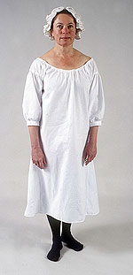 Example of a Pocket: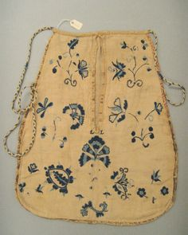
Example of a Stay (Corset) which is worn over a shift: 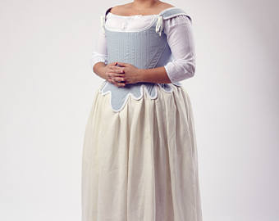
Example of a Fichu (worn over shoulders): 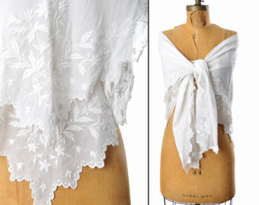
Example of a Short Gown and exterior petticoat: 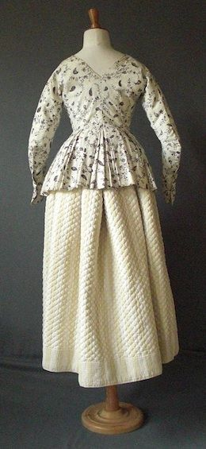
Example of Shift, Stays, two Pockets, and interior Petticoat: 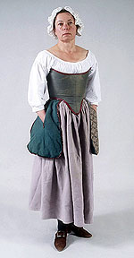
Male:
- Shirt
- Breeches
- Waistcoat
- Stockings (knee high: solid colors of neutral tones)
- Black/brown plain shoes
Examples of Breeches: 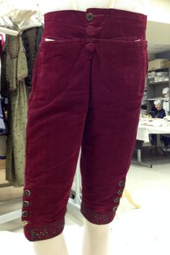 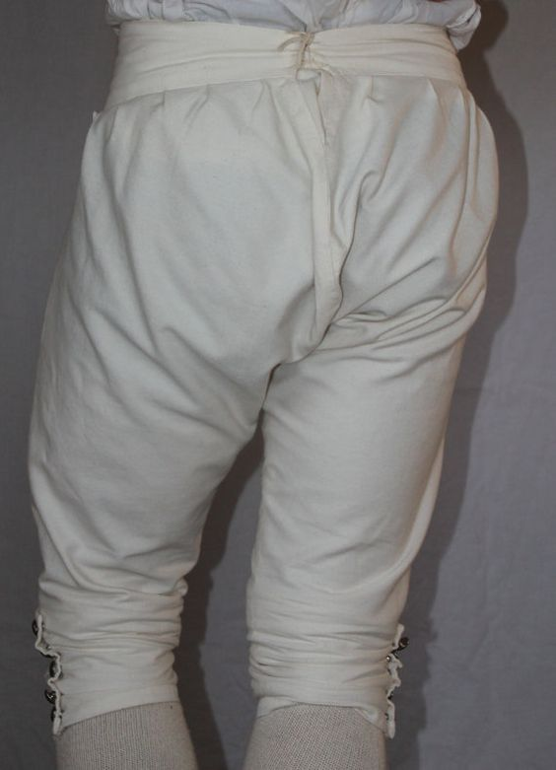
Examples of Shirts: 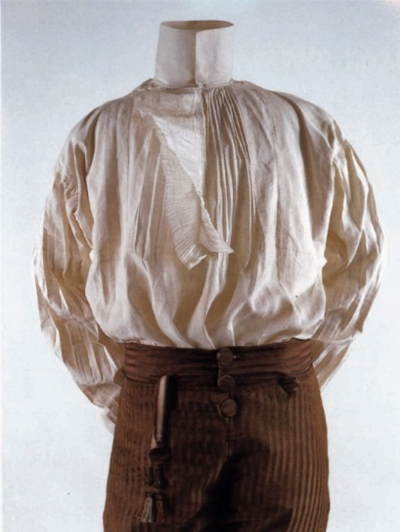 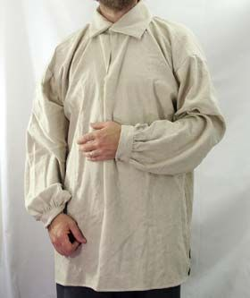 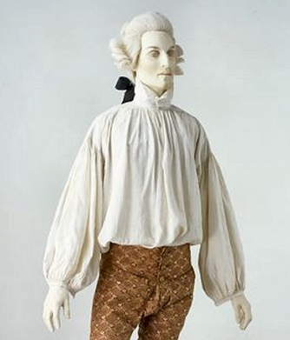
Examples of Waistcoats: 