EQUINE - CARE AND KEEPING OF HORSES (BEGINNER)
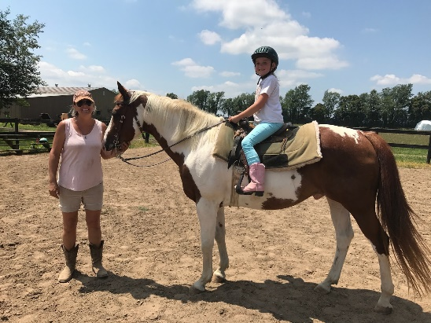
Information About the Instructor and Stables
Instructor Name: Cathy Kuminecz
Instructor Email: cakumi@comcast.net
Bittersweet Stables Email: bittersweetpetresort@gmail.com
Instructor Phone: (574) 276-1644
Bittersweet Stables Phone: 269-684-7361
Bittersweet Website: Horse riding lessons & Trail rides- Bittersweet Pet Resort & Stables ...
Owner and Instructor Bio:
Sandra Stern has owned and operated the Bittersweet for 22 years. Bittersweet has been working with the Niles homeschool for many years. Bittersweet was the first provider of Equine studies for homeschool partnership in the area. Sandra has ridden her entire life, has taught the homeschool classes and summer riding classes. She is involved in every aspect of Bittersweet.
Cathy is Bittersweet’s riding instructor. Cathy is entering her 10th semester of teaching beginner and intermediate equine studies. She provides riding lessons and trail rides at Bittersweet. She is the owner of an 18 year old horse, Mozart and a three-year old horse named Thunder. She encourages and accommodates all riders with safety, care, and patience. She worked as a teacher's aide for many years in the South Bend School system before deciding her passion was working with children and horses.
Website: www.bittersweetpetresort.com

Information About the Course
This course will be offered Fall 2019
Time and Days: Beginner: 10:00 am - 12:00 pm Wednesday or Thursday
Fall 2019: September 4th- October 23rd
Ages: 8-12 years old
Location: Bittersweet Pet Resort and Stables, 2100 Weaver Road, Niles, Mi 49120

Description:
These classes will consist of teaching basic horse knowledge. Students
will learn safety around horses, breeds around the world, colors of horses,
basic parts of horses, general horse terms, grooming tools, and cleaning up
after a horse.
Optional riding component would include walk only for beginners.
The additional $10.00 for the riding component is payable directly by the family to the instructor and will be collected the first day of class.

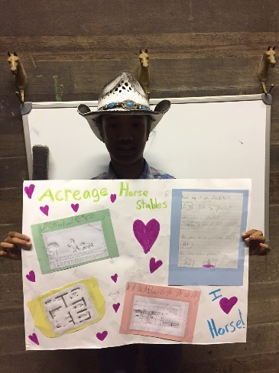

Fall 2019
- Breeds around the world
- Uses of horses
- How to trailer a horse
- Walk the walk
- Pieces and parts
- How is the horse measured?
- Whinnies Nickers, and snorts,
- Review vocabulary, take test, and implement patterns as well as games on horseback

