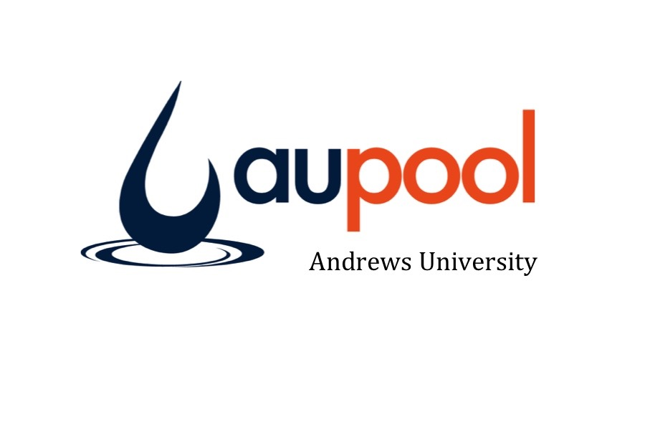
Swim n Gym
A 8 lesson program. Participants Attend Wednesday 1:30-3:30pm. First hour is Swimming: including both instruction with certified instructors and free time then they transition to the Gymnastics area on the 3rd floor for the next hour for gymnastics skills and coordinated movement.
- Registration Required via our website Opens Dec 3
- Attendance taken at Front Desk

1:30-2:20pm Swim Lessons/Play
2:30-3:30pm Gymnastics

Wednesday Dates:
Jan 24, 31, Feb 7, 14, 21, 28, Mar 7, 14

Lifeguarding
An American Red Cross 2 year certification including Lifeguarding, CPR, and First Aid. This University course includes Online blended learning material. Participants must be 15 years old to participate and successfully pass the physical pre-recs on the first day of class.
January 22 3:30-6:30pm, & Aor 2-26 3:30-6:30pm Tuesday - Thursday

Learn To Swim

A 16 lesson program of group swim lessons for children of all abilities. Participants choose Sunday & Wednesday OR, Tuesday & Thursday to attend for both 8 lesson sessions. Children are placed in levels based on previous swimming experience. First time students must attend a placement test during designated times to complete registration
- Registration Required via our website Opens Dec 3
- Attendance taken at Front Desk
Winter Session 1:
Jan 21- Feb 15
Winter Session 2:
Feb 18- Mar 15, (includes President’s Day)

Levels & Time
With-Parent Level 1 & 2 (Age 6m-3y) 4:30-4:55pm
Preschool Level 1 (Age 3y-5y) 4:30-4:55pm
Preschool Level 2 & 3 (Age 3y-5y) 5:00-5:25pm
Level 1, 5, 6 (Ability) 4:30-5:25pm
Levels 2, 3, 4 (Ability) 3:30-4:25pm & 5:30-6:25pm
- Berrien Partnership only allows private lessons for students with special needs
- Niles Partnership will cover private lessons up to $350 & according to teacher availability.

Junior Lifeguarding

A 11 lesson program that builds a foundation of knowledge and skills in preparation for Lifeguarding certification. Students learn about CPR, First Aid, and prepare for the physical pre-requisites for Lifeguarding as well as an introduction to rescue skills. Participants Must be Age 11-15 and have at least be able to swim a full lap on their front and back with a breathing pattern
- Registration Required via our website Opens Dec 3
- Attendance taken at Front Desk
* Monday 5:00-6:30pm
Dates: Jan 29, Feb 5, 12, 26, Mar 5, 12, 26
Apr 2, 9, 16, 23

Youth Swim Club

A 11 lesson program that builds endurance. Students work towards personal best scores and earn medals for swimming specific distances in 10min swims.
- Registration Required via our website Opens Dec 3
- Attendance taken at Front Desk
* Monday 5:00-6:30pm
Dates: Jan 29, Feb 5, 12, 26, Mar 5, 12, 26
Apr 2, 9, 16, 23

